Comic World

UI Prototype Document

Version 1.0

Revision History

| **Date** | **Version** | **Description** | **Author** |
| --- | --- | --- | --- |
| 19/08/2023 | 1.0 | Update screens | Ngô Quốc Quý  Phạm Phú Toàn  Nguyễn Thuận Phát  Nguyễn Trần An Hòa  Tô Khánh Linh |

Table of Contents

**1. Introduction 4**

**2. Screens 4**

*a. Home Page 4*

*i. Home Page before login/sign up (guest). 4*

ii. Home Page after login/sign up (member). 5

*b. Comic Page 6*

*c. Reading Page 7*

*i. Page when reading . 7*

*ii. Page when transforming/choosing to a new chapter. 8*

*d. Profile Page 9*

*i. Member 9*

*ii. Upload 9*

*iii. Admin 10*

*e. Create Comic Page 11*

*f. Upload Chapter Page 12*

UI Prototype Document

# Introduction

This document has a purpose of providing the UI Prototype of the Comic World website by using Figma to sketch an overview of the main pages. These key scenarios were sketched following the description in the Use Case Specification.

The scrope of this document is to deliver to client and user the view of how the Comic World system would be after the development and is also the guideline for the Comic World team to follow and develop the GUI of the system.

# Screens

## Home Page

### Home Page before login/sign up (guest).

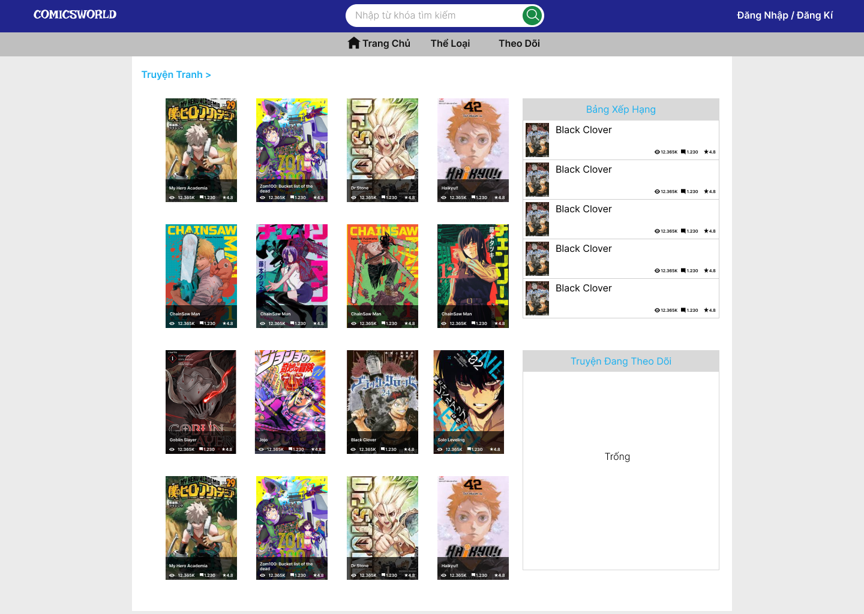

The homepage body has a list of comics that are posted by uploaders. User Click on the image to read the comic. Beside the comic list is the ranking board, which shows the most readed comics. The following board lies under the ranking board, this board shows the comics users following. If the user has not yet logged in, it will show nothing.

Users can search for comics by using the search bar on the header. The login/register button lies on the right corner of the header, users click here to login/register to the website. The navigation bar is under the search bar, it has three items, “Trang chủ” redirects users to the homepage, “Thể loại” redirects users to the comic type page, “Theo dõi” redirects users to the page that show all the comics user following.

### Home Page after login/sign up (member).

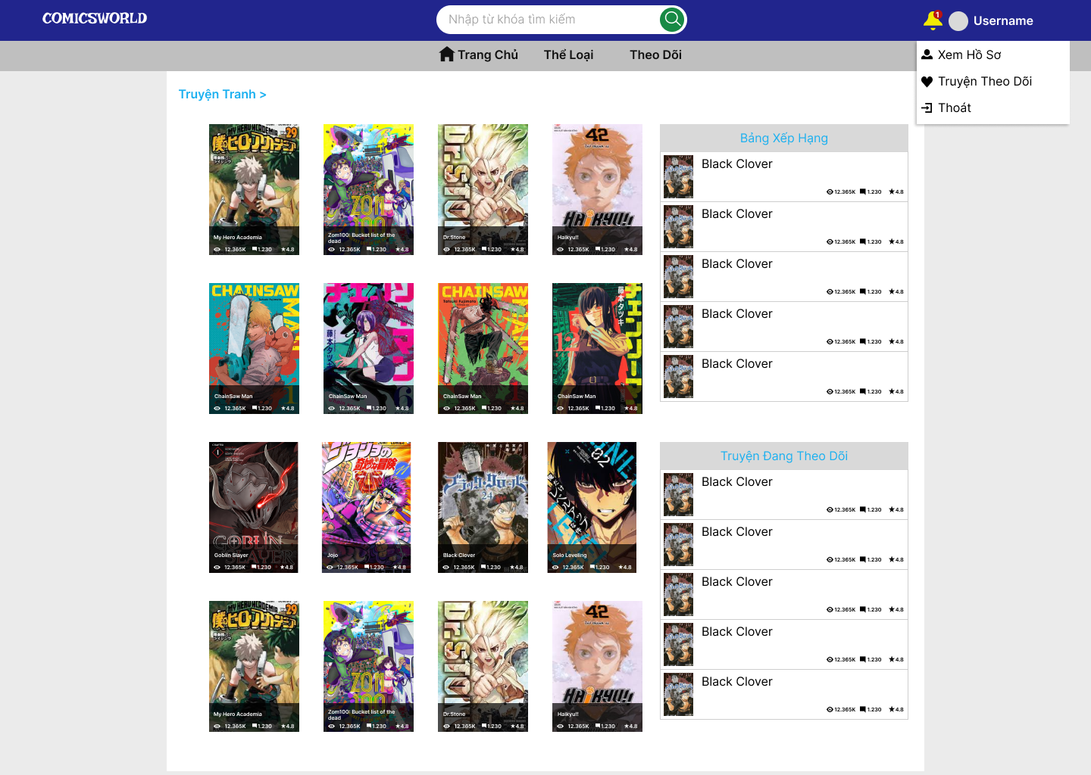

## Comic Page

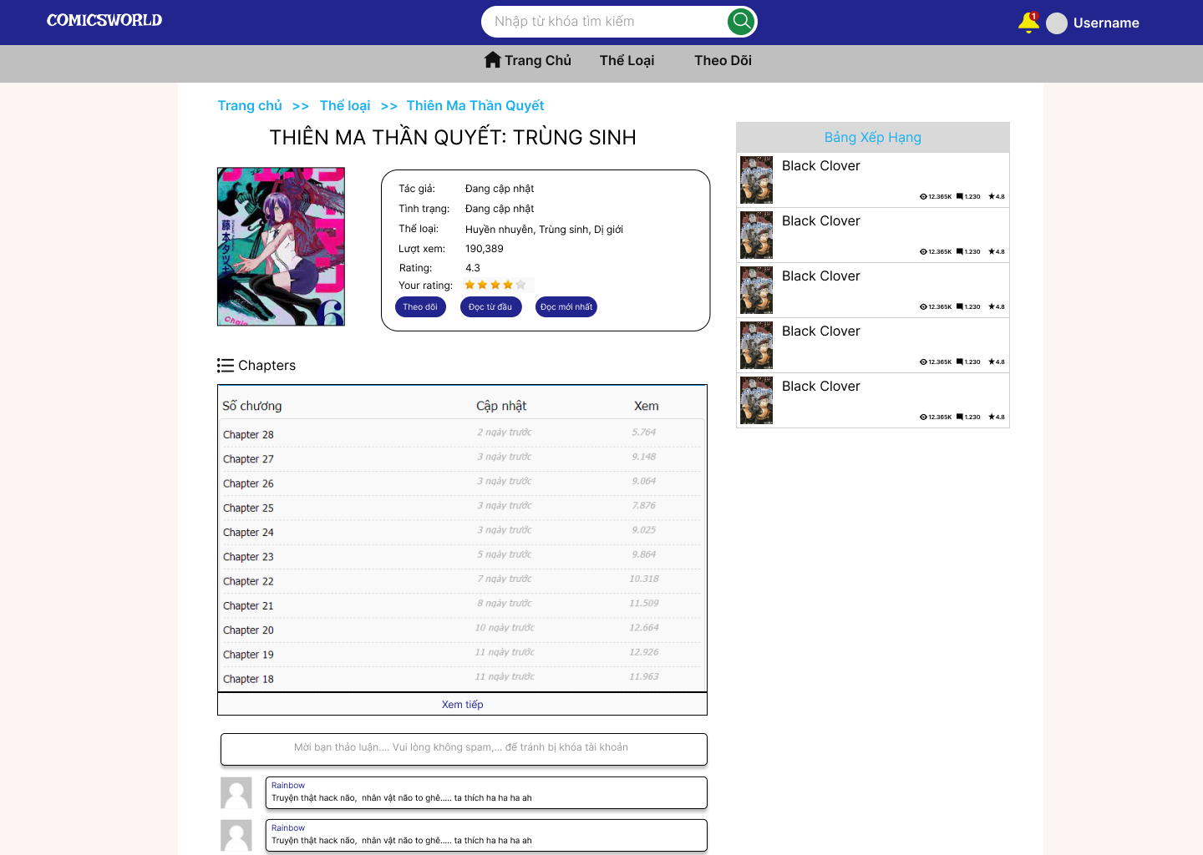

Page to represent the information of a comic on the website. In this page, users can choose the chapter of the comic to read and follow the comic if they want by pressing the following button. The button “Đọc từ đầu” let them read the first chapter of comic and the button “Đọc mới nhất” let users read the latest chapter.

They also can view the comment of the comic at the comment section or express their opinions about the comic by commenting their feelings.

User can rate the comic based on their emotion from 1 to 5 start by pressing the start rating section

## Reading Page

### Page when reading .

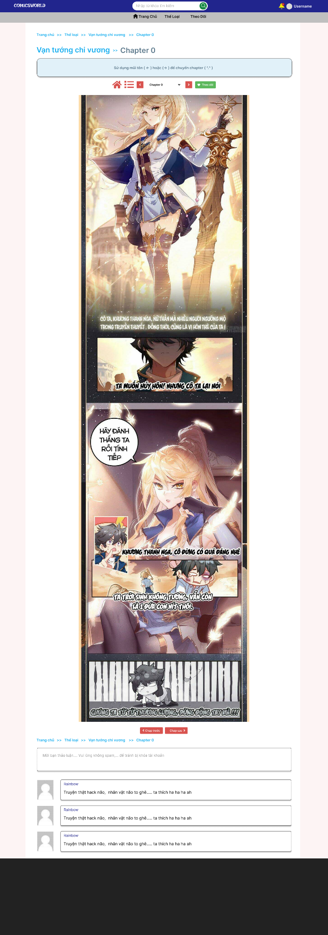

This page shows each chapter content of the comic. On this page, users can read chapter content. They can also follow the comic by pressing the follow button ,go back to homepage by pressing on the home button, comic page by pressing on list button, next chapter and previous chapter by clicking on the right arrow button and left arrow button. If they want to go to one specific chapter they can click on the chapter button and a pop up will show up.

User scroll to read the comic’s content. They can also comment on one specific chapter.

### Page when transforming/choosing to a new chapter.

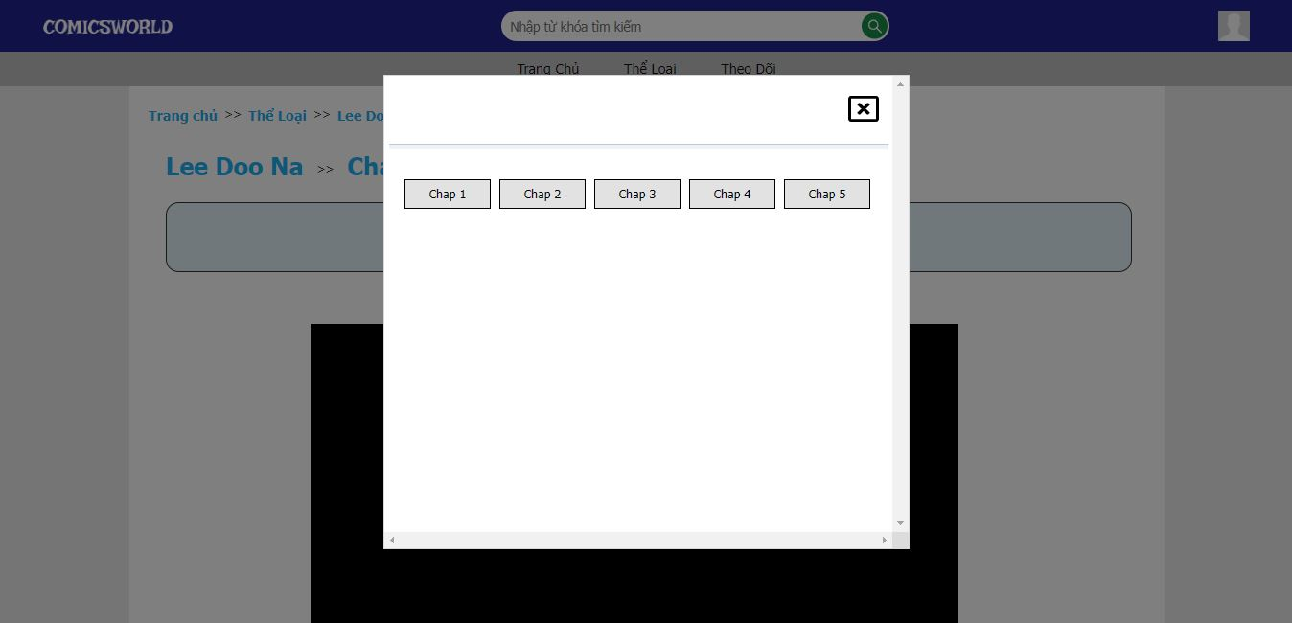

When clicking on the chapter button a popup shows up and lists all the chapters the comic has. Users can click on any chapter they want to read and the website will redirect them to that chapter.

## Profile Page

### Member

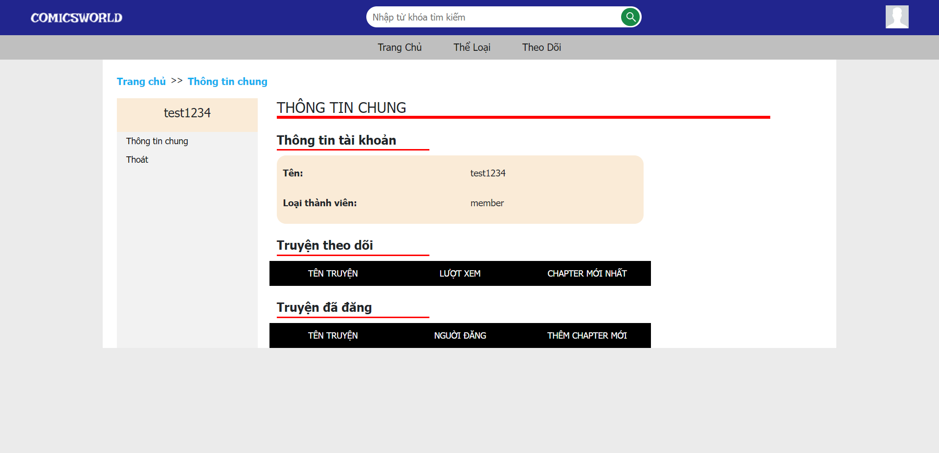

Profile page shows some information about the users. The list function at left will different when the role changes. In the main page, the username and type of user will be shown.

The list of following comics are shown to help users access the comic more conveniently.

The list of uploaded comics are also shown but if users are members, the list will be empty.

### Upload

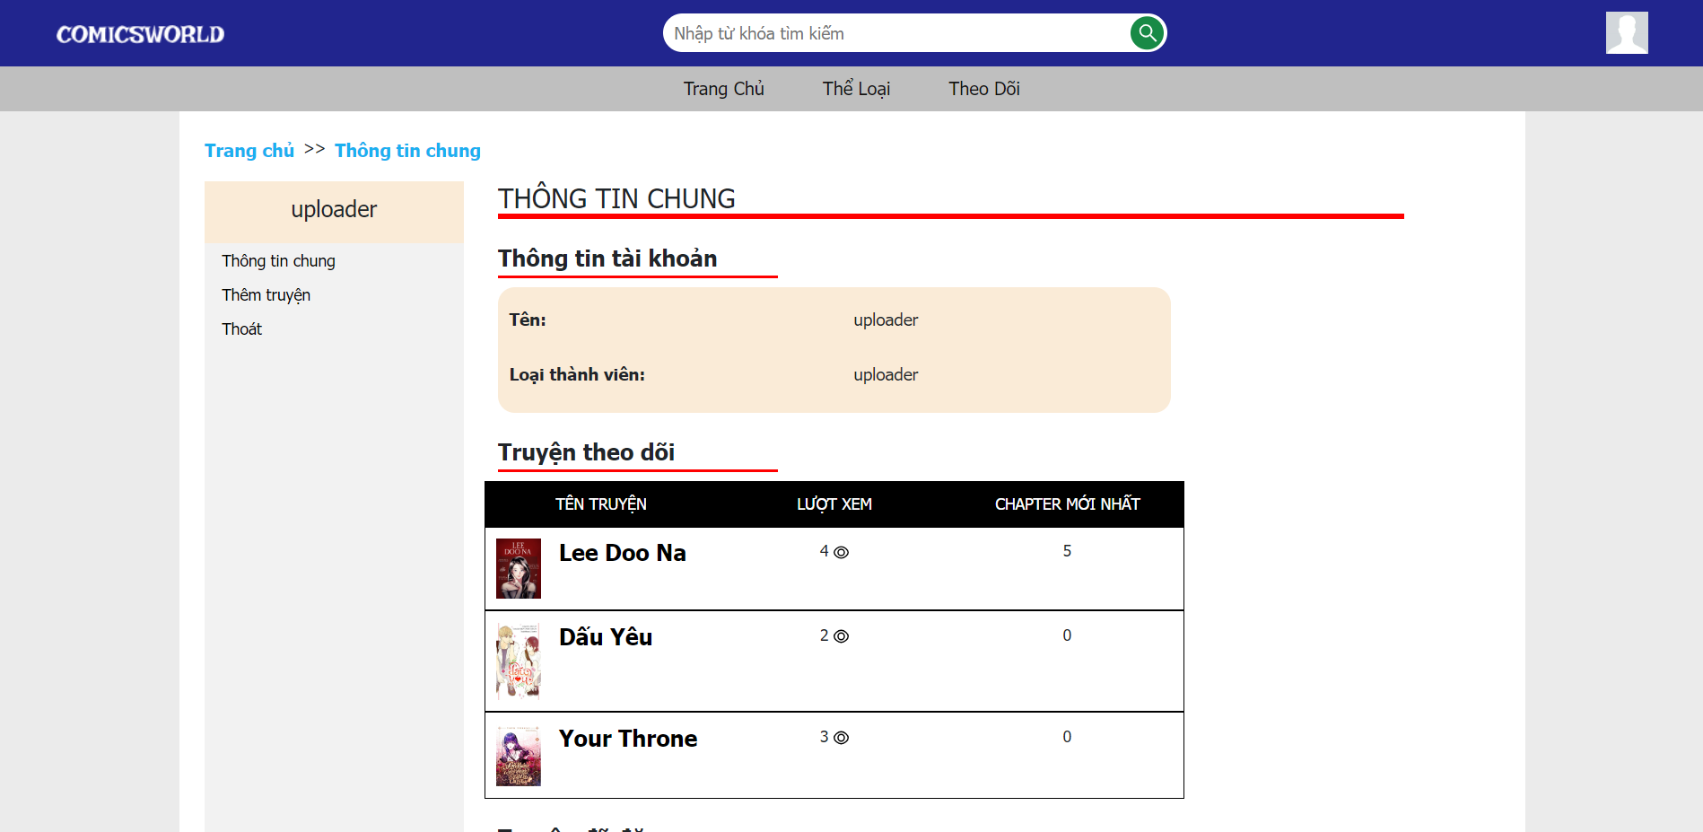

Similar to member, but the function of uploader is added more, this is to create new comics, and the list of uploaded comics will be shown the comics they uploaded.

### Admin

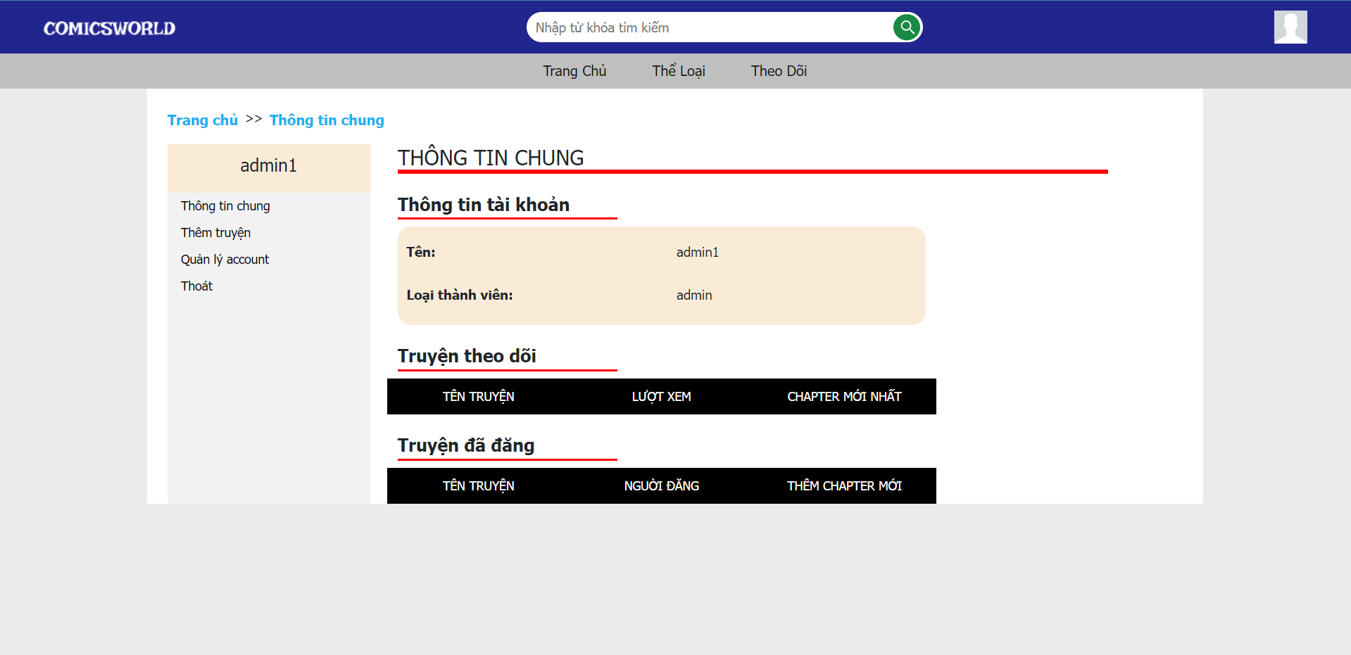

Admins also have the screen similar to member and uploader, but they have two more functions that is to add new comics, and manage the account.

## Create Comic Page

This page allows uploaders to create a new comic. They have to fulfill all the information of the comics. To upload the cover of the comic, they have to click on the “Đăng ảnh” button, and the system will show the file explorer for uploaders to choose the right image. The “thể loại” input will show the list of type that the uploaders can choose one. “Ngày” field will display a calendar to choose the day that the uploader wants. “Lưu” will save the comic to the database, and the “Hủy” button will link to the homepage directly. 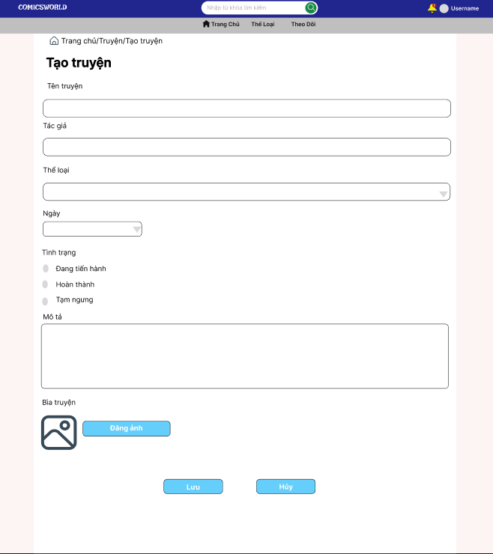

## Upload Chapter Page

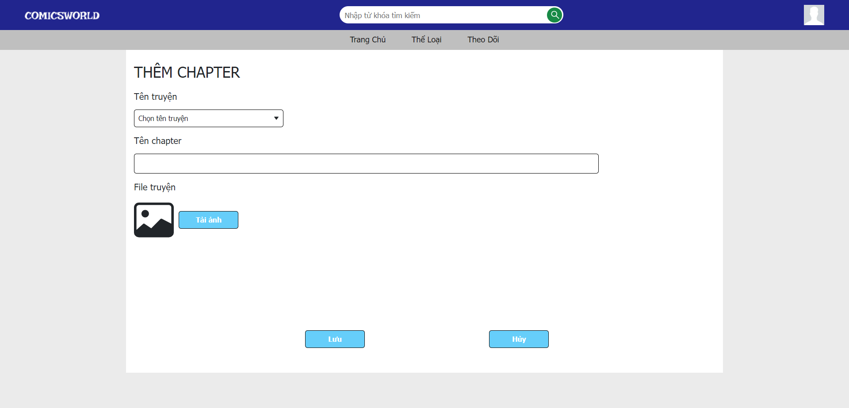

The upload chapter page allows uploaders to upload new chapters of their comics. The page has a selection field for uploaders to choose the name of the comic they want to post a new chapter, then they type the name of that chapter and click the “Chọn ảnh” button to select the chapters file.

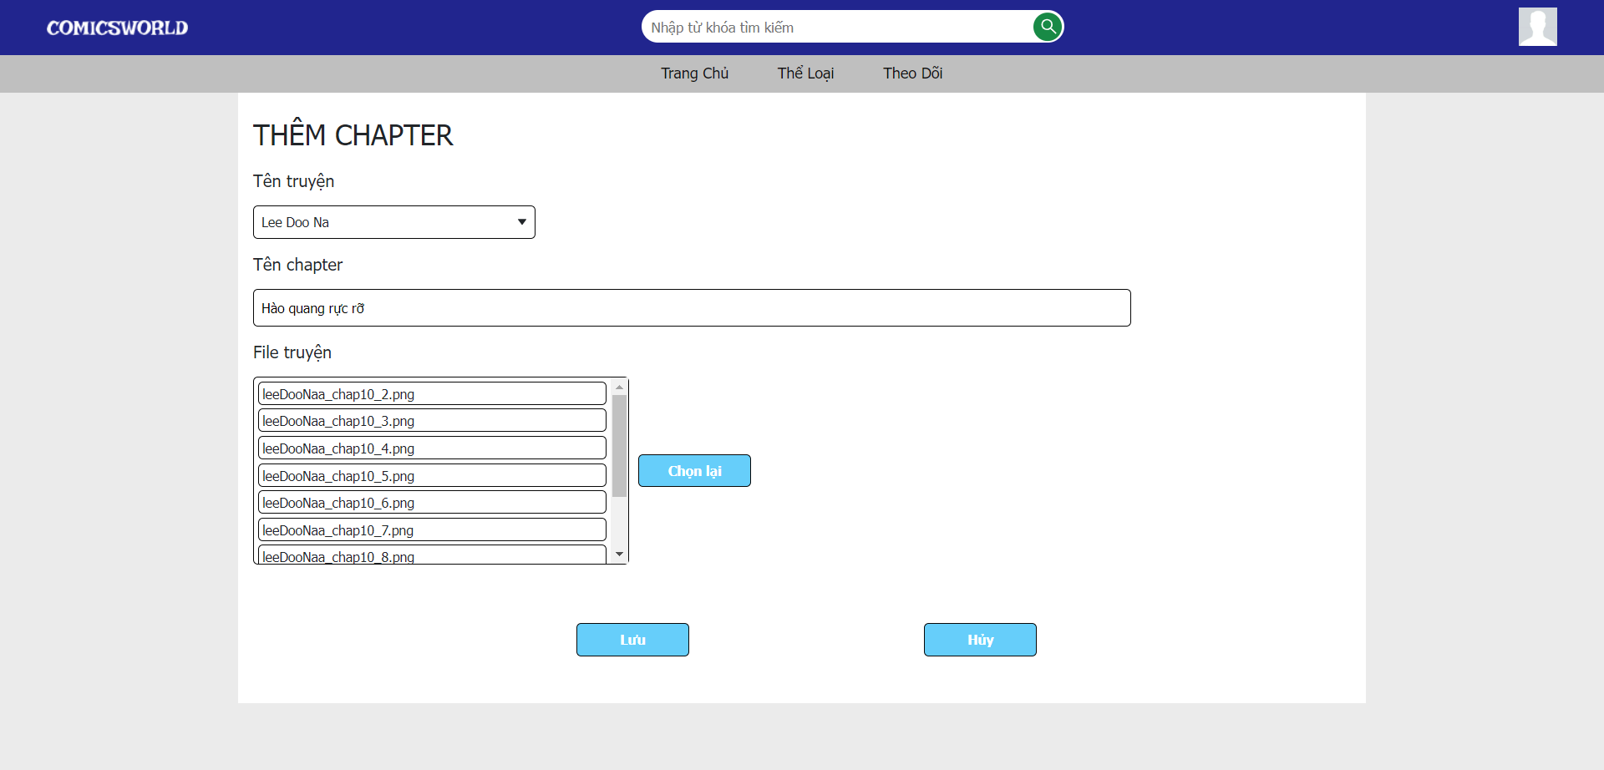

After completing all of the steps above, the uploader can see the files he selected. If the uploader wants to change the files, he can click the “Chọn lại” button. The uploader clicks the “Lưu” button to post the chapter, to cancel uploading the chapter, the uploader can click the “Huỷ” button beside the “Lưu” button.